# Homework #2: Mastering the Basics of SQL Server

|  |
| --- |
| * This is an individual assignment, and is worth 20 points. * The due date is 2:30 (sec 01) / 7:00 PM (sec 76) on Tuesday, January 28. * You have to use the “Homework #2-Tasks.docx” file to provide your answers. Change this file name according the naming convention below. * Use the following naming convention: homework, underscore, last name, first initial, and extension (e.g., Homework #2_ImG.docx). If you do not follow the convention, I will deduct 1.0. * Do not copy any of the sample screenshots provided as illustrations. * Report any issues before the deadline. |

(**Task 1: 5 points**) Complete Task #2 through Task #4 while placing your sql files in Queries. Show in a screenshot that your Homework 2 project in Solution Explorer contains **three** sql files in **Solution Explorer**.

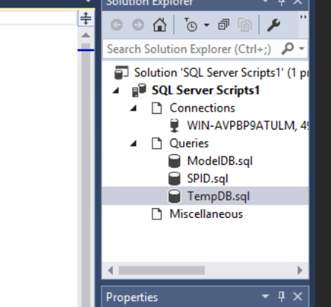

**(Task 2: 5 points**) Show in a screenshot that **DatabaseLog_test** table is created in **MySecondDatabase**, and **not** in **MyFirstDatabase**.

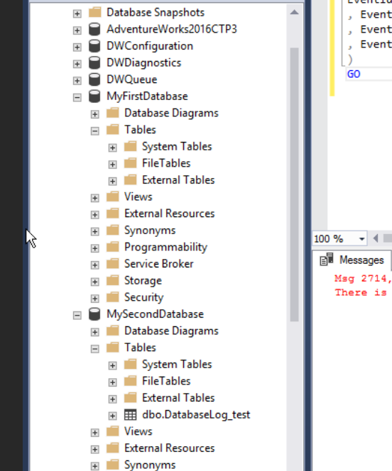

(**Task 3: 4 points**) Create the three temp tables listed above and show their existence using the SELECT command above. Attach a screenshot.

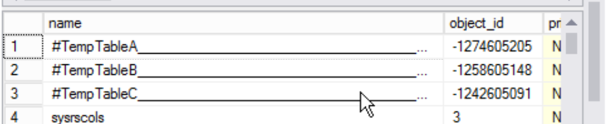

(**Question: 1 points**) When do we use temporary Tables? List three scenarios. When do we use table variable over temp table? For the answers, go to the link above.

We use temp tables when we are doing large number of row manipulation in stored procedures, when we need to replace the cursor, and when we have a complex join operation. We use table variable when we have less data than what we need to use a temp table.

(**Task 4: 5 points**) Fill in **all** the blanks. Keep in mind that you have made a connection via a dynamic port not the default number. Your answers to the second column must be consistent with the connection you made.

|  |  |  |
| --- | --- | --- |
|  | **Name/Number** | **Description (definition)** |
| SPID | 55 | Server Process ID |
| SID | 0x0105000000000005150000007C98BDF441F8B4DD1677D940F401 | Sever-Level ID |
| principal_id | 1 | ID of principal |
| net_library | TCP/IP | Protocol in use |
| local_tcp_port | 49214 | Network port in use |

In addition, show the result of each of the four queries in a screenshot.

